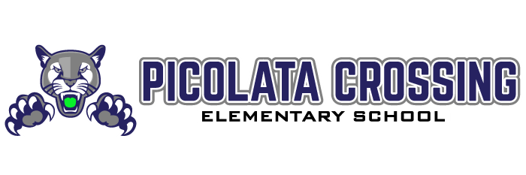

www.pce.stjohns.kl2.fl.us

Ken Goodwin, Ed.D.
Principal
Ewa Kolk
Assistant Principal

September 3, 2020

Dear Puma Families:

We’ve had a very positive start. Thank you for being prepared and patient! As we all get acquainted with a new way of learning, it is important to allow time for adjustment to the routines and expectations. We know you committed to the model that would best suit your family.

In the event you need to request a change from Distance Learning to Brick & Mortar or vice versa, our process is outlined below.
- Contact your school to request the change. (a link will be on our school website September 8th to request a change).
  - If requesting a move to Distance Learning, please watch our distance learning video for an overview of responsibilities and expectations: https://www.stjohns.k12.fl.us/online-learning/.
  - If requesting a move to Brick & Mortar, loaner devices provided by the school will be collected.
- Schools will review requests each Thursday.
- Families will be advised of decisions on Friday.
- Students will continue participating in their current model until notified of the new placement.
- Please note that a schedule change and/or teacher change may be necessary when a student moves from one model to the other.

