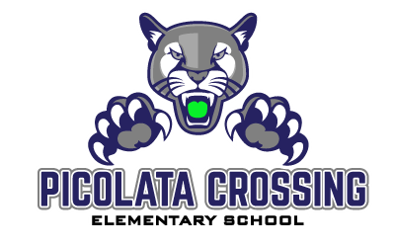PCE’s Summer Stretch Program Weekly Exit Ticket (KG-1st)
To receive a reward for your hard work, turn this paper in during the first week of school!
Week #1: Draw a picture to show your favorite activity on the Summer Stretch Program this week.
Week #2: Share one interesting fact that you learned this week from the Summer Stretch Program (draw or write).

OVER
You’re off to a great start! Keep up the awesome work!

Week #4: What new words did you learn on the Summer Stretch Program this week?

Week #3: What one thing did you learn this week that you plan to share with your parents or a friend (draw or write).

Week #5: After completing this week of the Summer Stretch Program, what do you still need help learning (draw or write)?

Be sure to complete the online survey at the end of the Summer Stretch Program!

